**2) d)** I computed X3[k] and X5[k] using MATLAB. The results are shown in **Figure 1**.

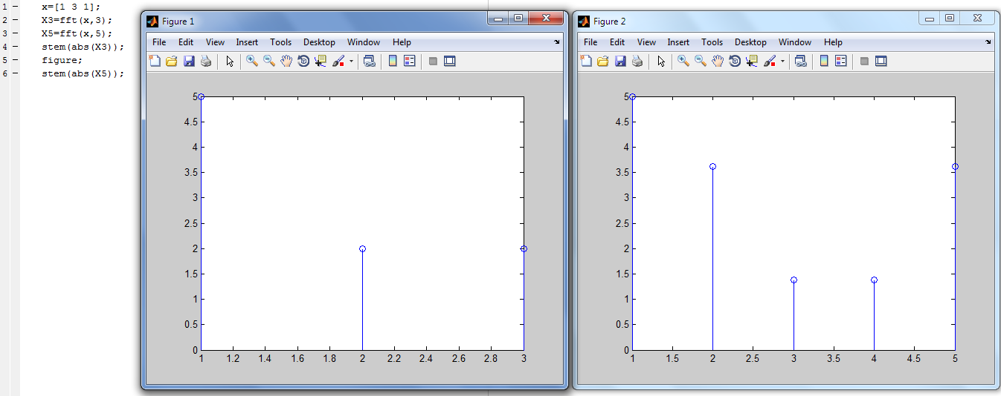

**Figure 1**

**8) c)** I computed the response of the system to each of the input segments by using MATLAB. The code I wrote for this purpose while calculation the response of the 1st input segment is given in **Figure 2**.

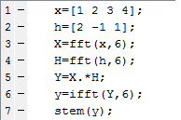

**Figure 2**

Responses of the system to 1st, 2nd and 3rd input segments are shown in **Figure 3**, **Figure 4** and **Figure 5**, respectively.

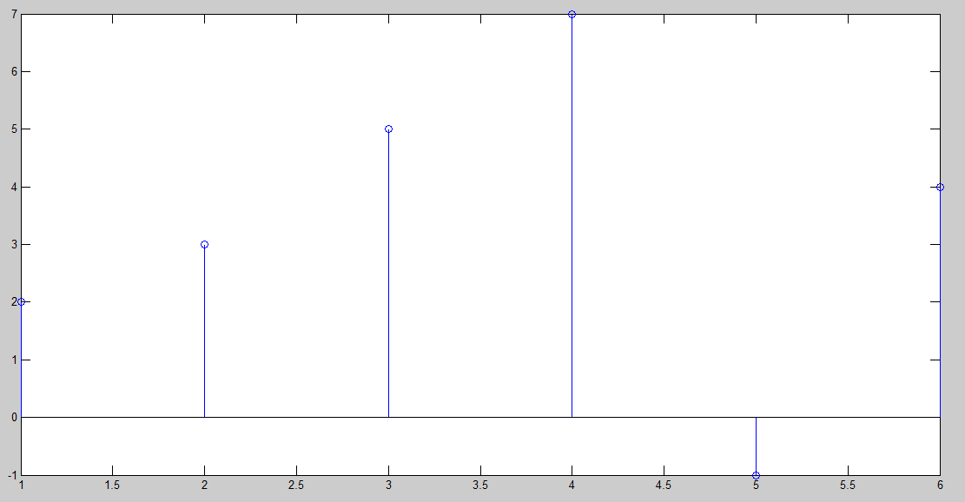

**Figure 3**

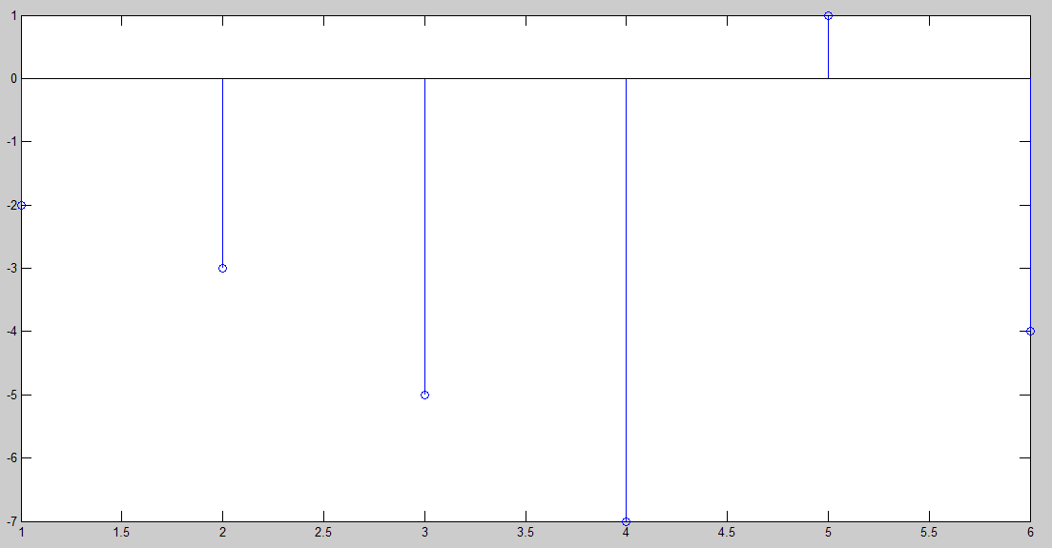

**Figure 4**



**Figure 5**